**Activities of P.G. Department of Commerce for the Session 2024-2025**

1. The Department of Commerce organized a General Assembly and an Extension Lecture on the Teachings of Swami Vivekanand Ji for the students of B.Com I & M.Com I on 12th August 2024.

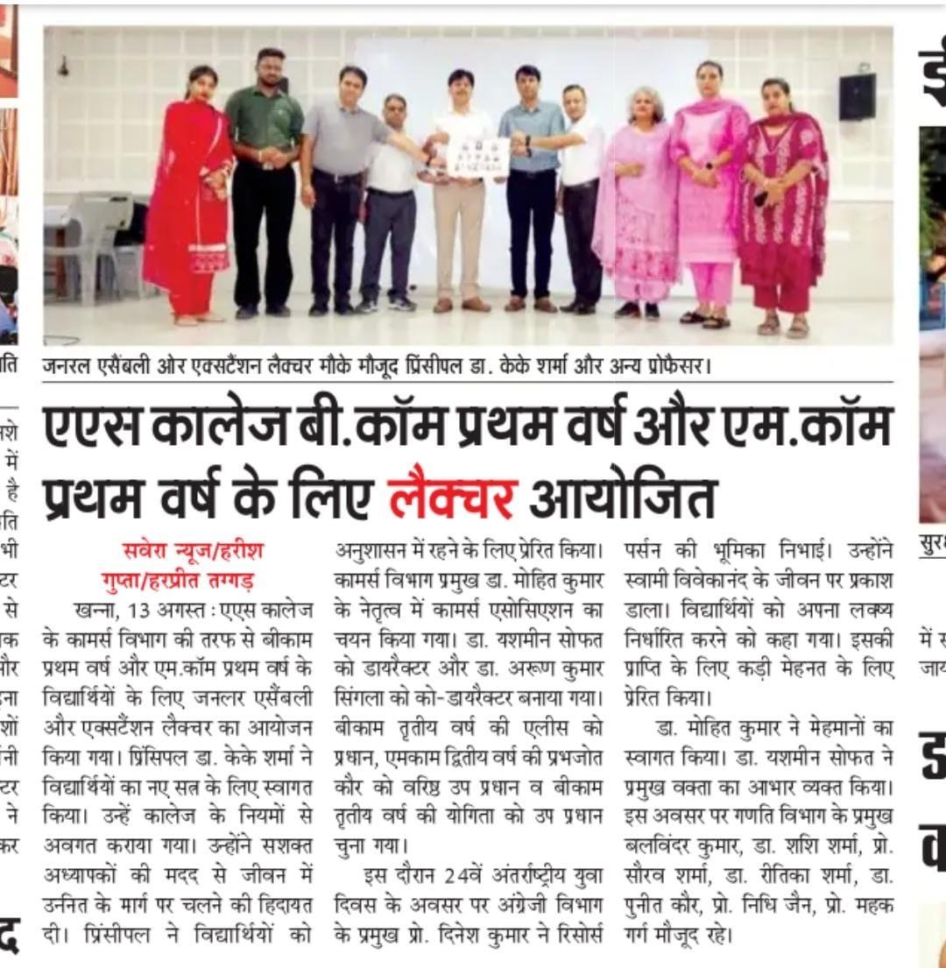

1. P.G. Department of Commerce organized a Book Fair held on 13th August 2024. The event, which took place in the commerce block on the college campus, brought together students, faculty and community members in a celebration of accounting, law, literature, learning & Cultural Exchange.

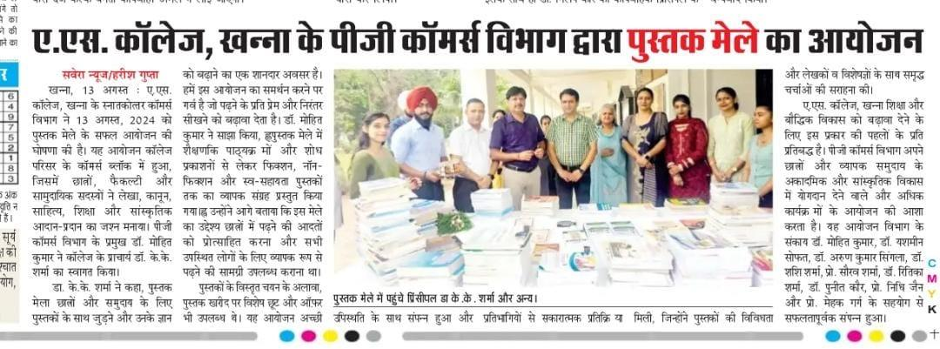

1. The Department of Commerce initiated UGC NET exam coaching for M.Com students, beginning in the 2nd week of August, with sessions conducted on a weekly basis.

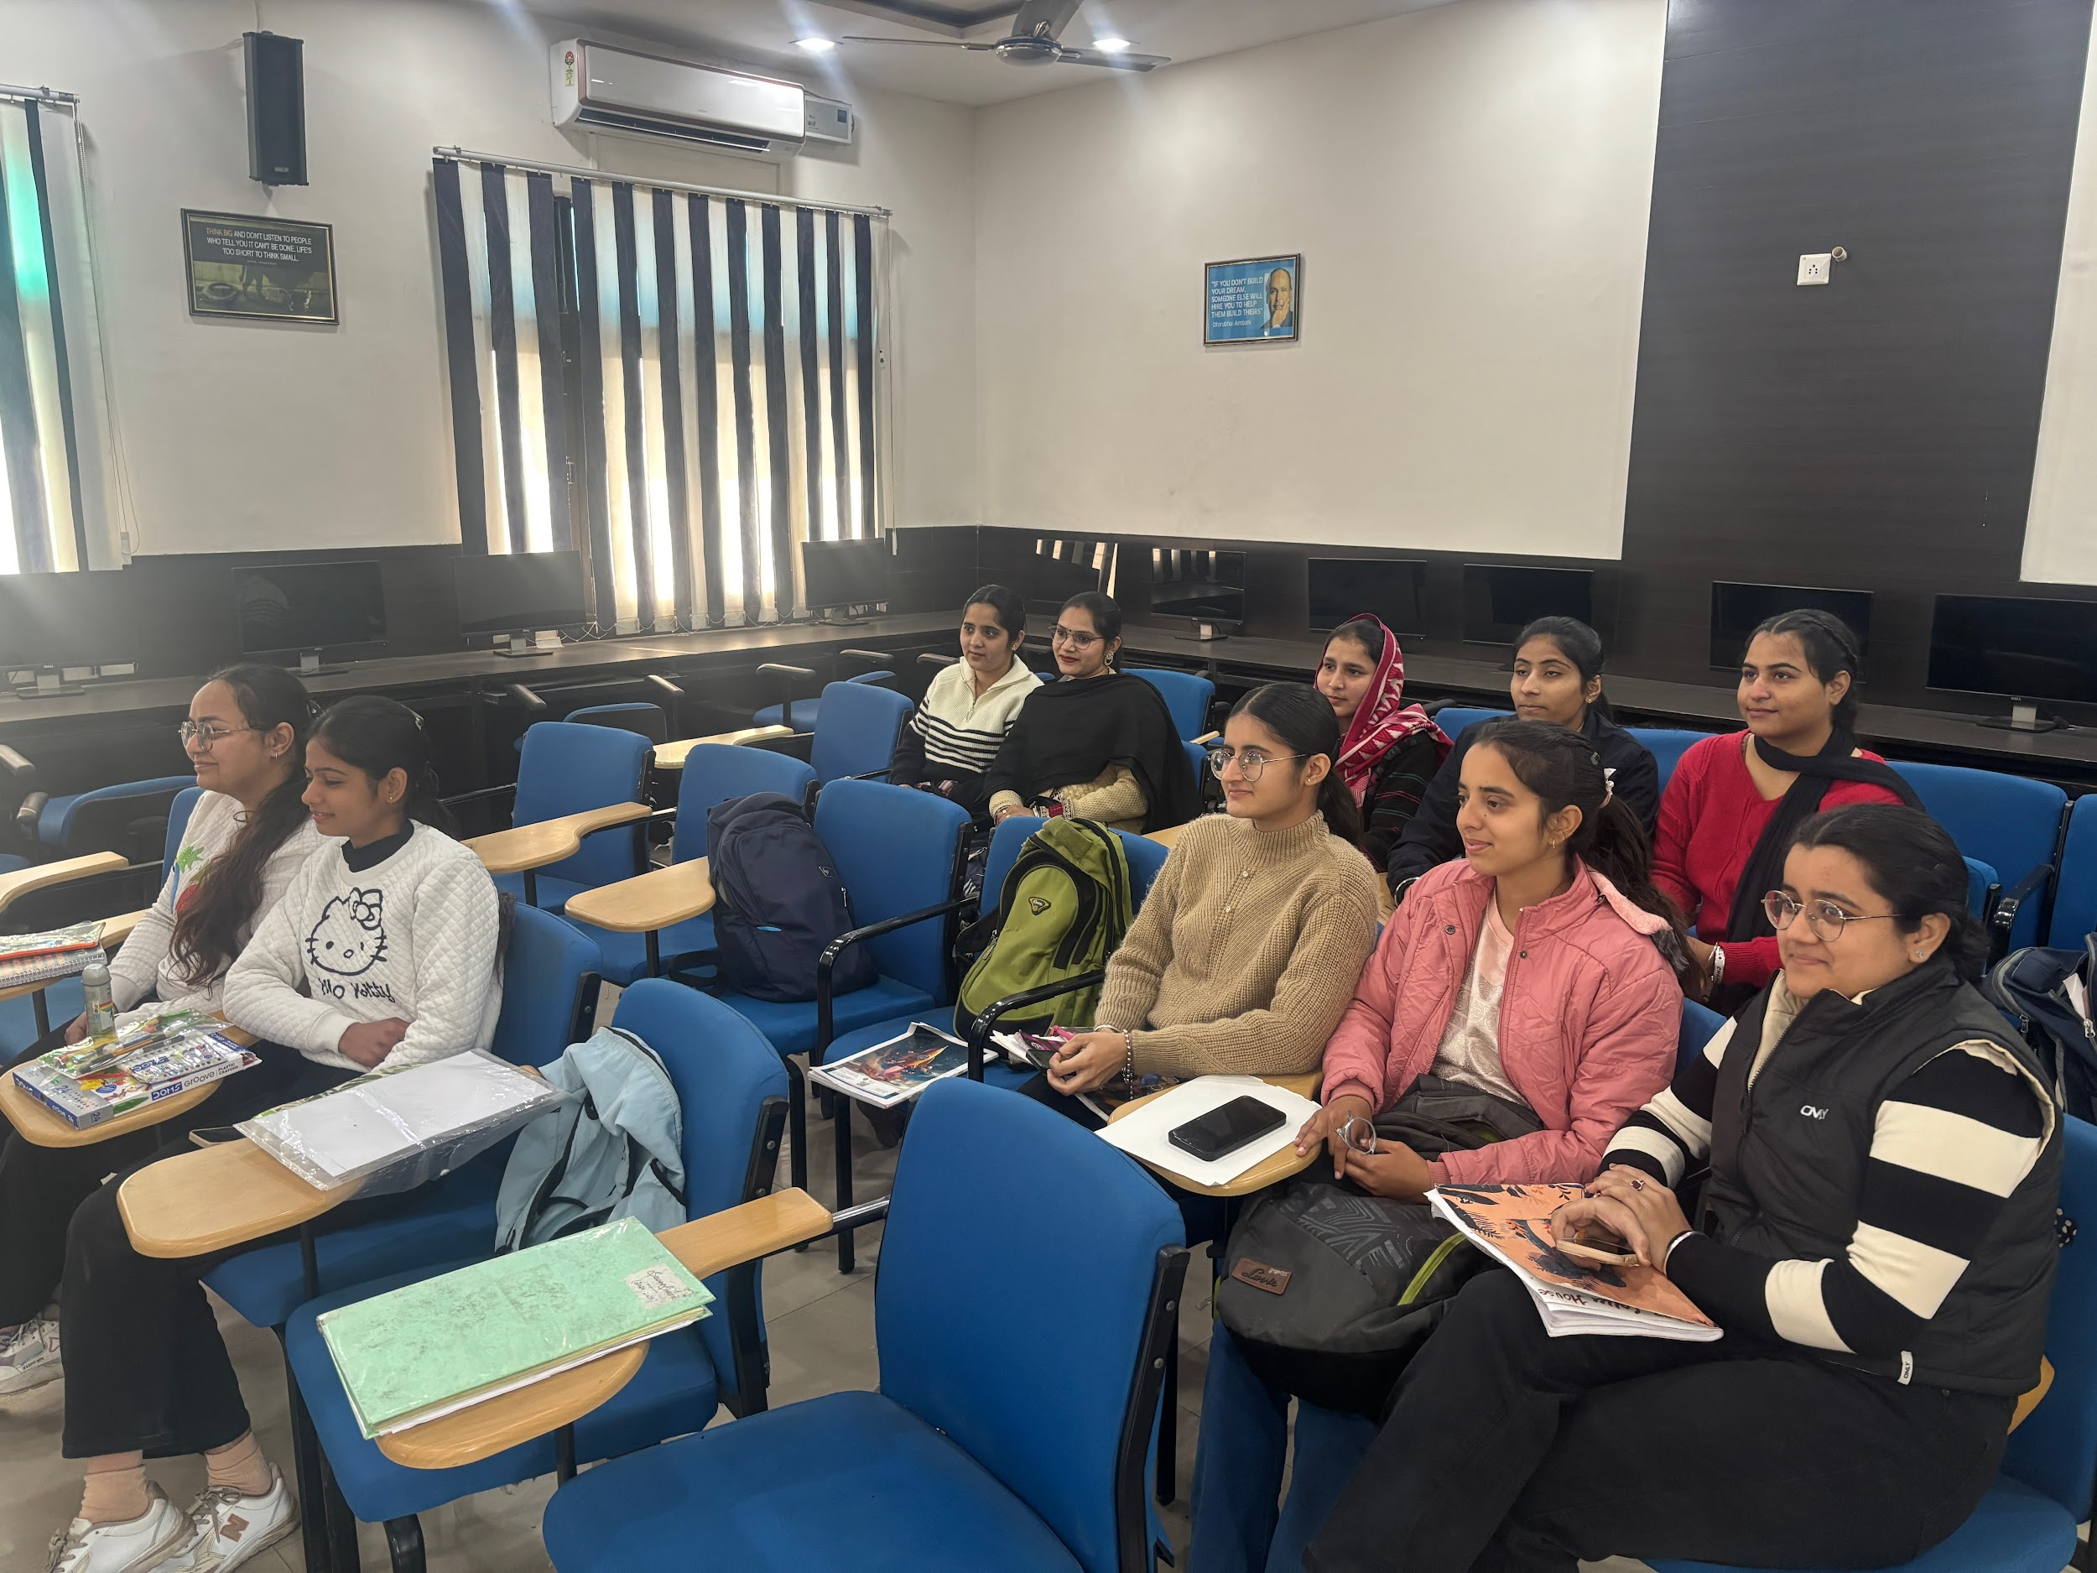

1. P.G. Department of Commerce celebrated world entrepreneurship day on 22nd August 2024. On this occasion Case studies Presentation and Poster-making competitions were held.

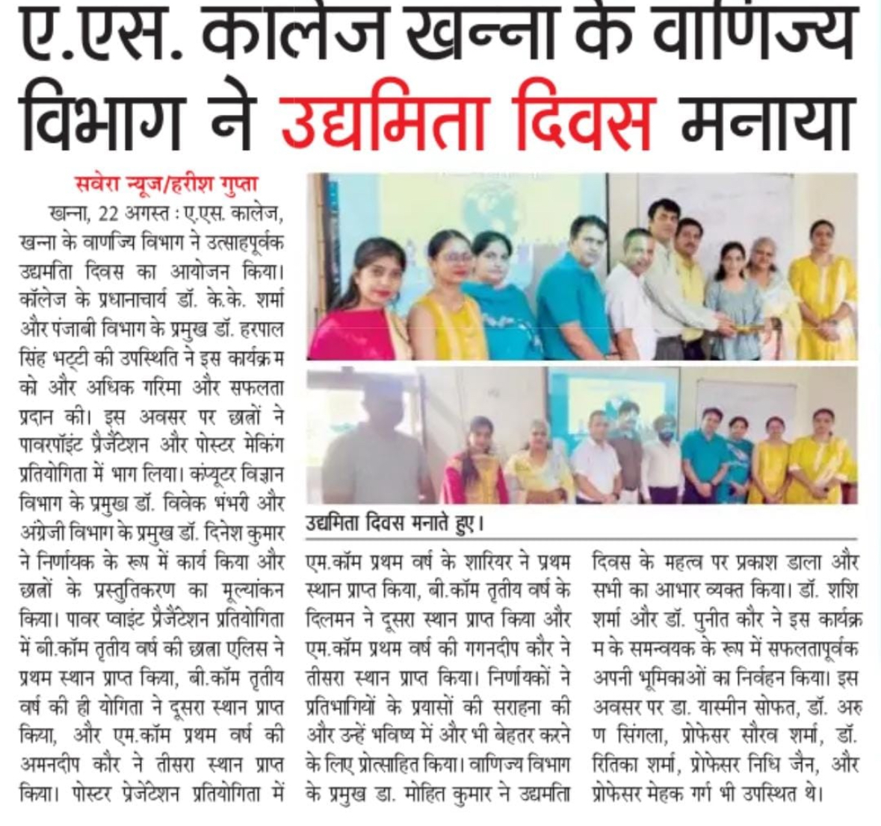

1. P.G. Department of Commerce celebrated Teachers’ Day on 5th September 2024 with great enthusiasm. The event honored educators for their dedication and contributions.

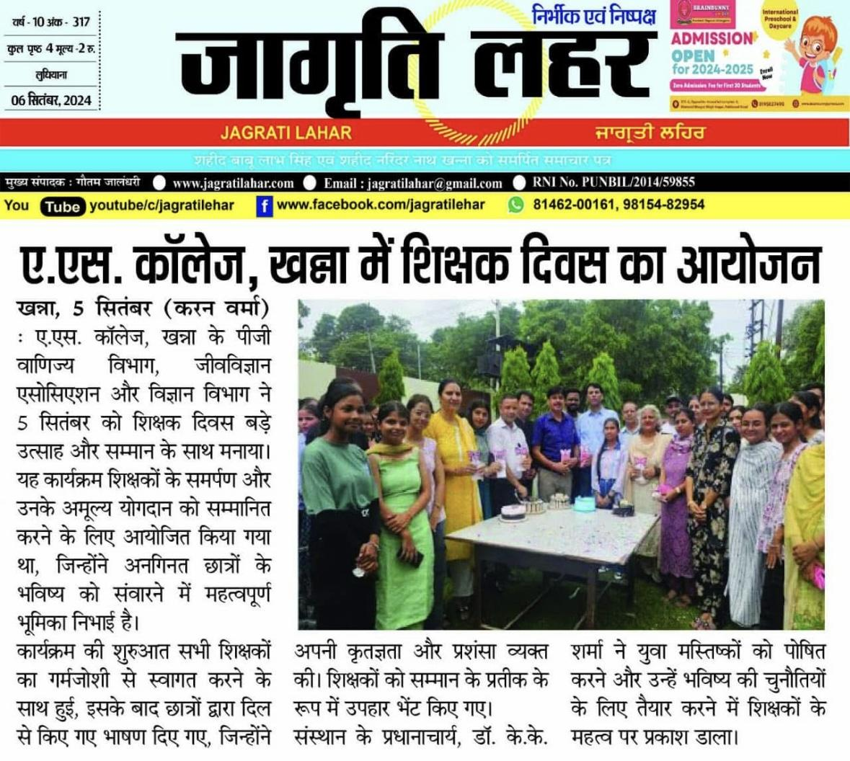

1. The Postgraduate Department of Commerce organized a special session for B.Com III and M.Com II students to enhance their interview preparation skills on 15th September 2024.

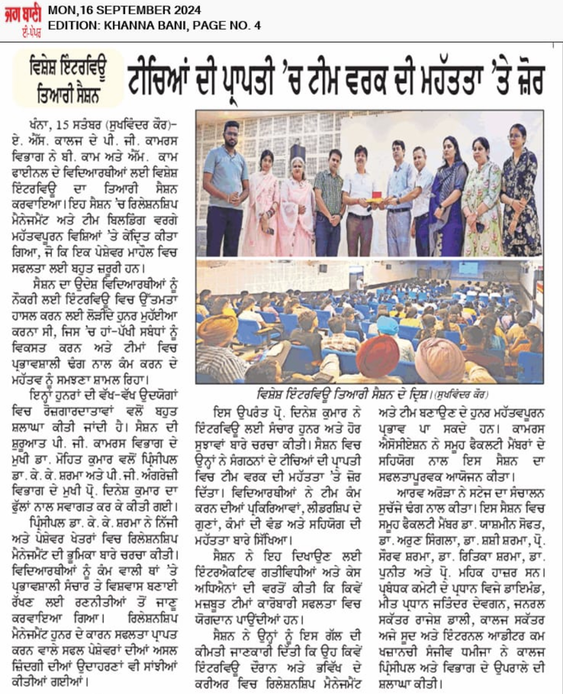

1. The department signed up MOU with Bajaj Finserv Ltd. and Launched a 4th batch of Certified Programme in Banking, Finance & Insurance on 20th September 2024.

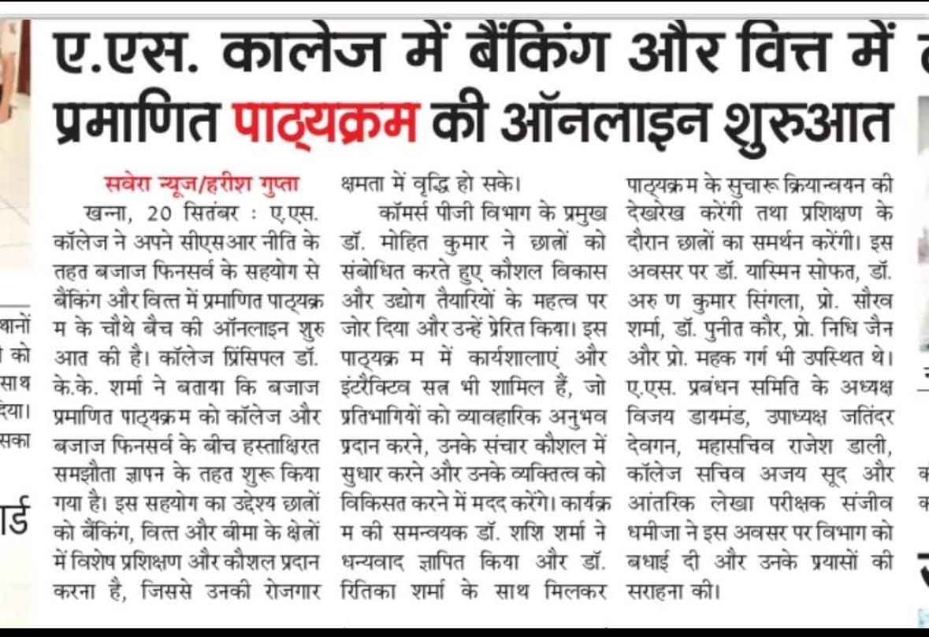

1. P.G. Department of Commerce recognized and honored 13 students for successfully qualifying the CA Foundation Examination on 5th November 2024.

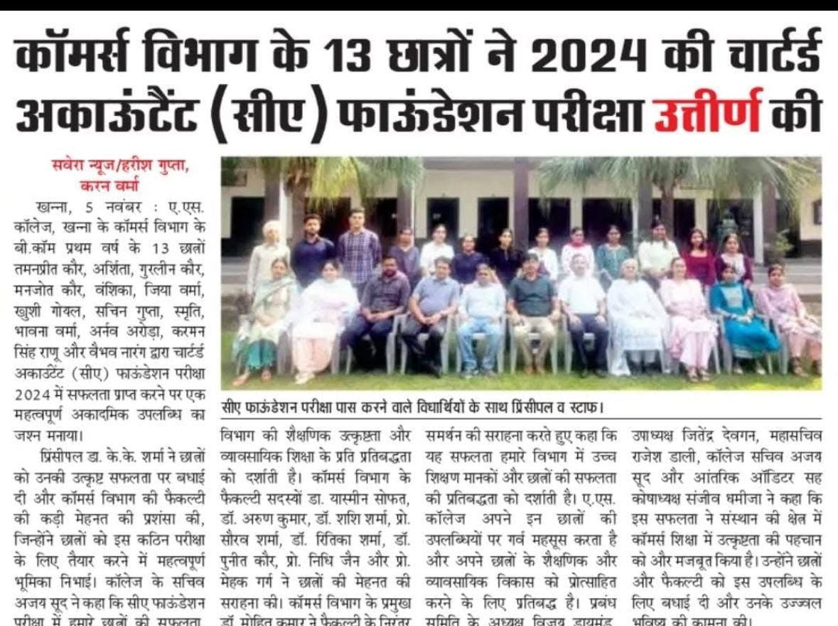

1. P.G.Department of commerce organised a career counselling webinar in collaboration with Plutus Education on 16th November 2024.

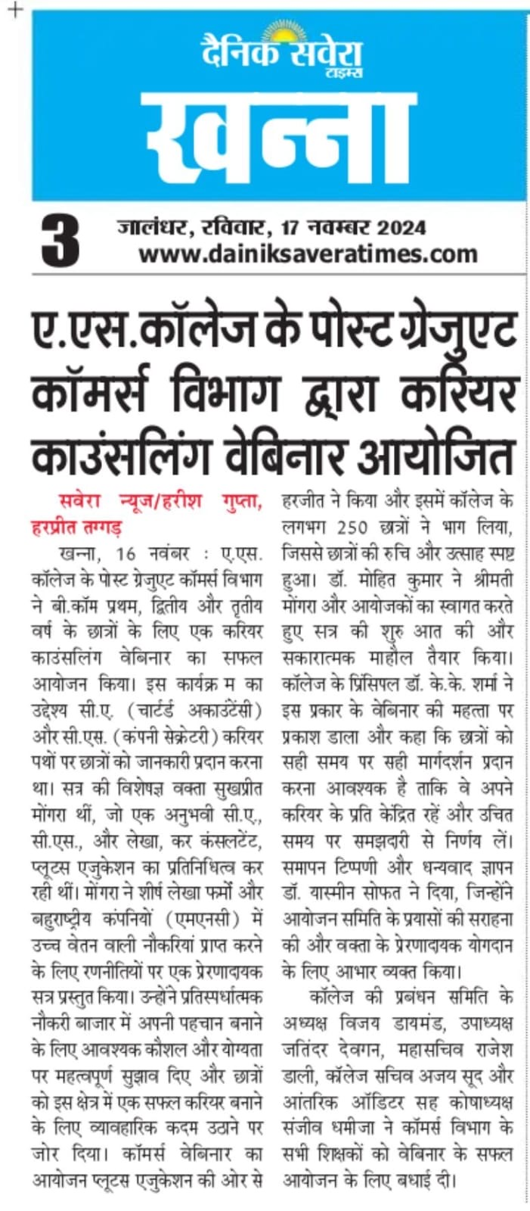

1. The Postgraduate Department of Commerce has organized a Logo Making Competition 30th January 2025. This competition aims to enhance creativity, brand awareness, and design skills, which are essential for commerce students in fields such as marketing, entrepreneurship, and corporate branding.

